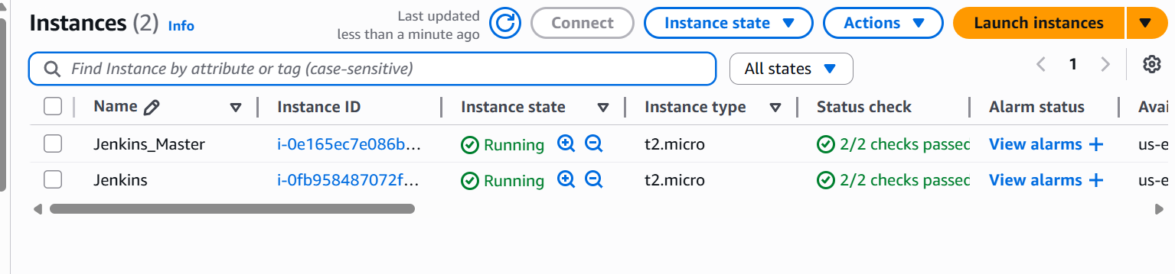

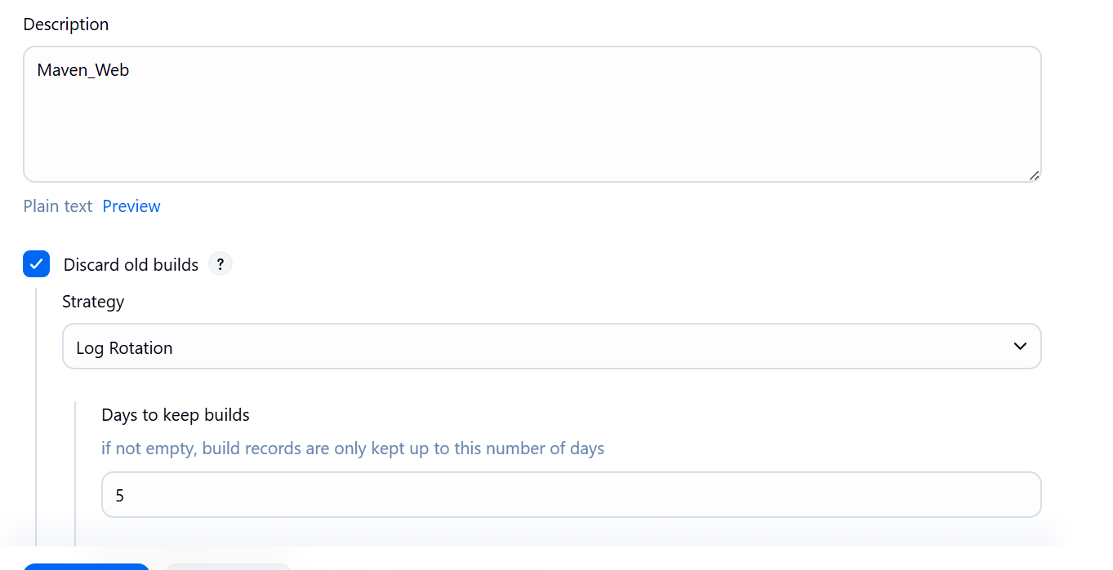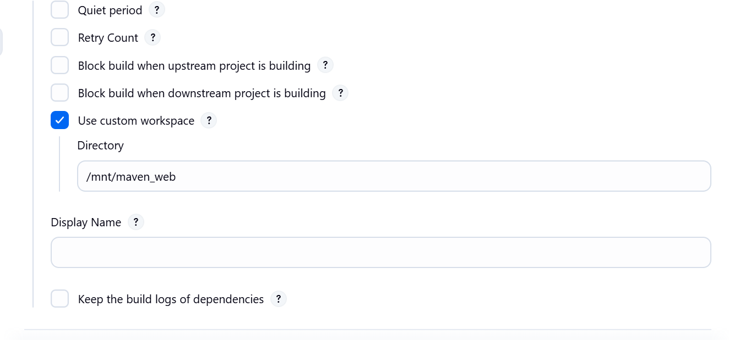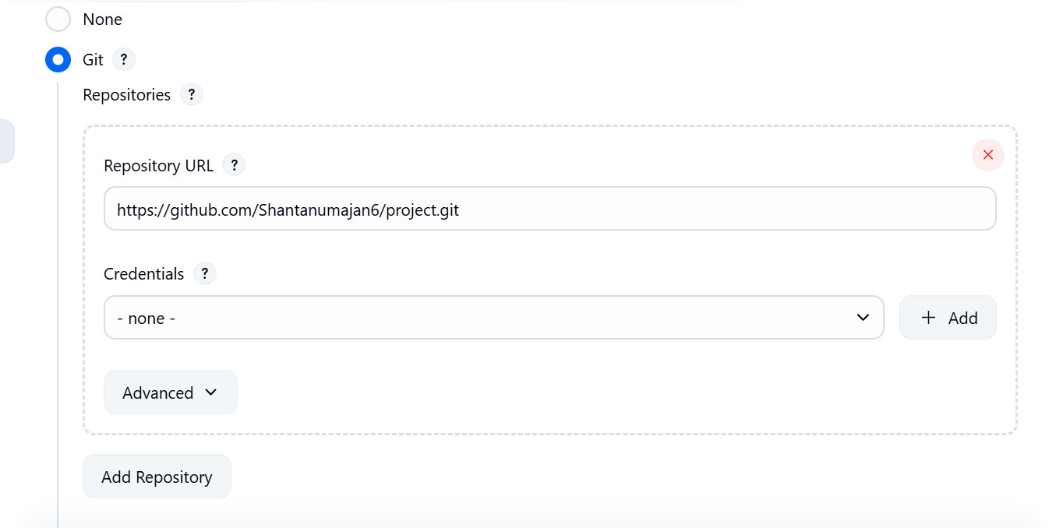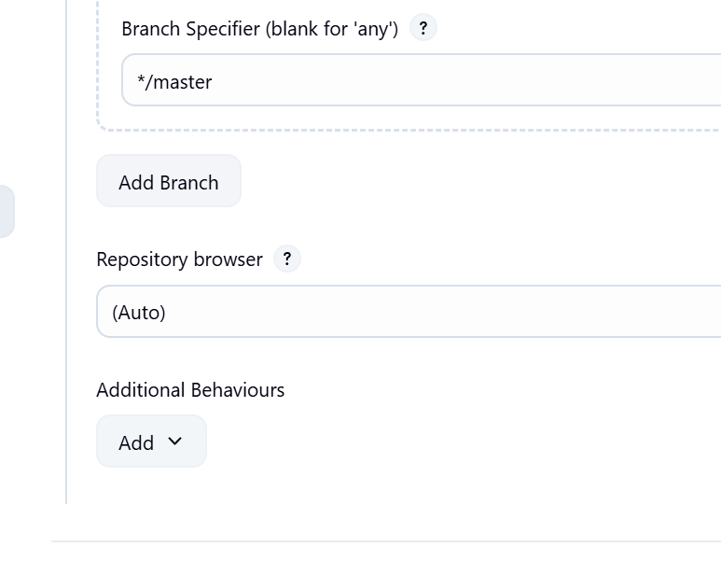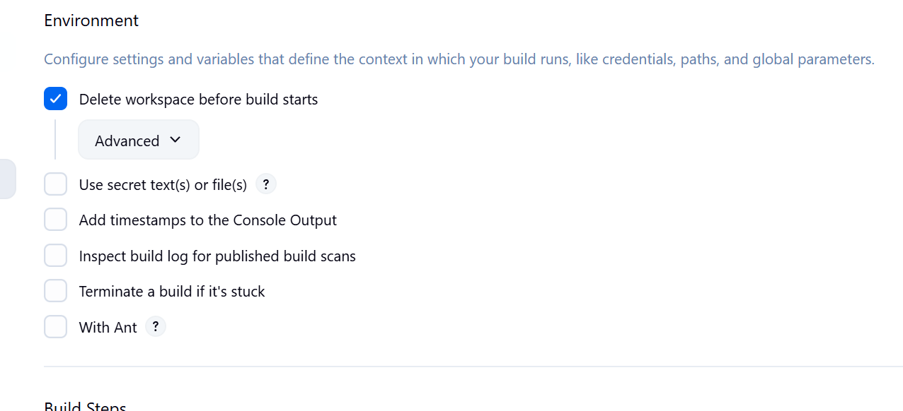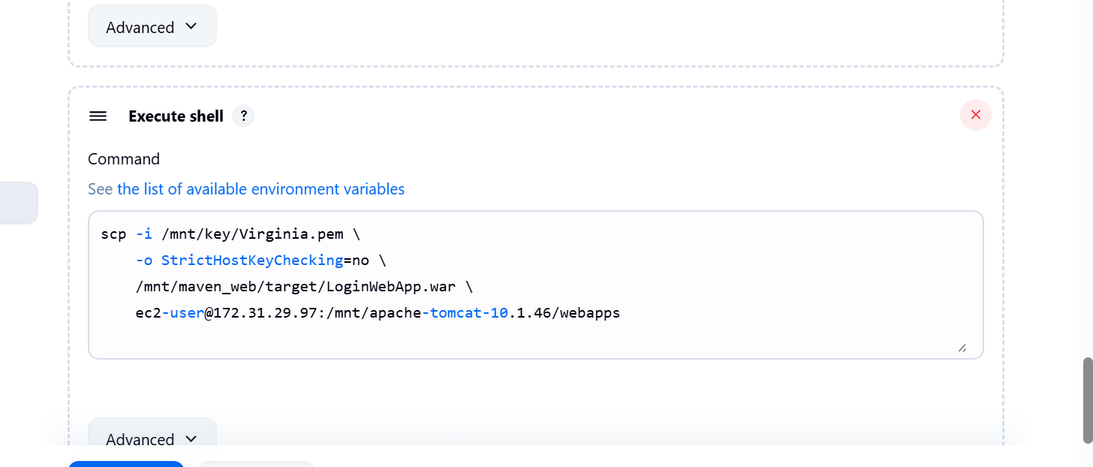

Master server page

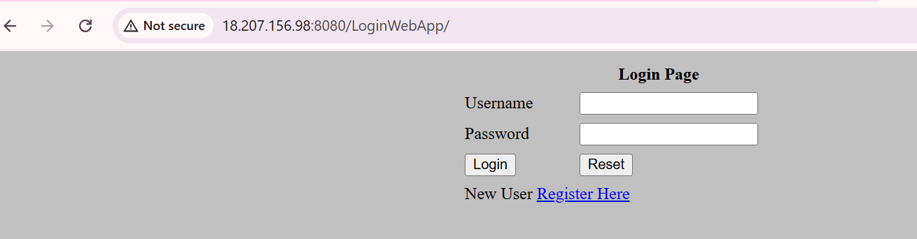

Remote server login page

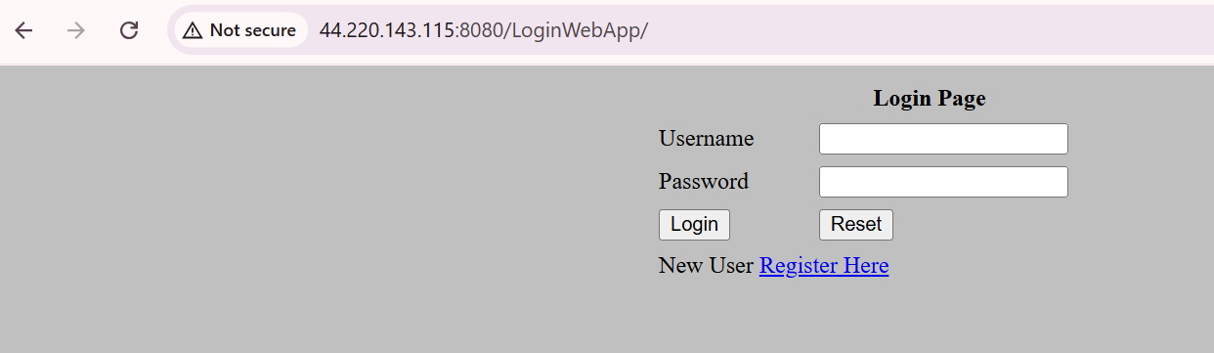

Console Out put

Started by user [King](http://18.207.156.98:8080/jenkins/user/king)

Running as SYSTEM

Building in workspace /mnt/maven_web

[WS-CLEANUP] Deleting project workspace...

[WS-CLEANUP] Deferred wipeout is used...

[WS-CLEANUP] Done

The recommended git tool is: NONE

No credentials specified

Cloning the remote Git repository

Cloning repository <https://github.com/Shantanumajan6/project.git>

> git init /mnt/maven_web # timeout=10

Fetching upstream changes from <https://github.com/Shantanumajan6/project.git>

> git --version # timeout=10

> git --version # 'git version 2.50.1'

> git fetch --tags --force --progress -- <https://github.com/Shantanumajan6/project.git> +refs/heads/*:refs/remotes/origin/* # timeout=10

> git config remote.origin.url <https://github.com/Shantanumajan6/project.git> # timeout=10

> git config --add remote.origin.fetch +refs/heads/*:refs/remotes/origin/* # timeout=10

Avoid second fetch

> git rev-parse refs/remotes/origin/master^{commit} # timeout=10

Checking out Revision df0ca2ac0b3d4a41c0c934238c993c4e34118c14 (refs/remotes/origin/master)

> git config core.sparsecheckout # timeout=10

> git checkout -f df0ca2ac0b3d4a41c0c934238c993c4e34118c14 # timeout=10

Commit message: "Update index.jsp"

> git rev-list --no-walk df0ca2ac0b3d4a41c0c934238c993c4e34118c14 # timeout=10

[maven_web] $ /mnt/Maven_build/apache-maven-3.9.11/bin/mvn clean install

[INFO] Scanning for projects...

[INFO]

[INFO] --------------------< com.javawebtutor:LoginWebApp >--------------------

[INFO] Building LoginWebApp Maven Webapp 1.0-SNAPSHOT

[INFO] from pom.xml

[INFO] --------------------------------[ war ]---------------------------------

[INFO]

[INFO] --- clean:3.2.0:clean (default-clean) @ LoginWebApp ---

[INFO]

[INFO] --- resources:3.3.1:resources (default-resources) @ LoginWebApp ---

[WARNING] Using platform encoding (UTF-8 actually) to copy filtered resources, i.e. build is platform dependent!

[INFO] skip non existing resourceDirectory /mnt/maven_web/src/main/resources

[INFO]

[INFO] --- compiler:3.13.0:compile (default-compile) @ LoginWebApp ---

[INFO] No sources to compile

[INFO]

[INFO] --- resources:3.3.1:testResources (default-testResources) @ LoginWebApp ---

[WARNING] Using platform encoding (UTF-8 actually) to copy filtered resources, i.e. build is platform dependent!

[INFO] skip non existing resourceDirectory /mnt/maven_web/src/test/resources

[INFO]

[INFO] --- compiler:3.13.0:testCompile (default-testCompile) @ LoginWebApp ---

[INFO] No sources to compile

[INFO]

[INFO] --- surefire:3.2.5:test (default-test) @ LoginWebApp ---

[INFO] No tests to run.

[INFO]

[INFO] --- war:3.4.0:war (default-war) @ LoginWebApp ---

[INFO] Packaging webapp

[INFO] Assembling webapp [LoginWebApp] in [/mnt/maven_web/target/LoginWebApp]

[INFO] Processing war project

[INFO] Copying webapp resources [/mnt/maven_web/src/main/webapp]

[INFO] Building war: /mnt/maven_web/target/LoginWebApp.war

[INFO]

[INFO] --- install:3.1.2:install (default-install) @ LoginWebApp ---

[INFO] Installing /mnt/maven_web/pom.xml to /root/.m2/repository/com/javawebtutor/LoginWebApp/1.0-SNAPSHOT/LoginWebApp-1.0-SNAPSHOT.pom

[INFO] Installing /mnt/maven_web/target/LoginWebApp.war to /root/.m2/repository/com/javawebtutor/LoginWebApp/1.0-SNAPSHOT/LoginWebApp-1.0-SNAPSHOT.war

[INFO] ------------------------------------------------------------------------

[INFO] BUILD SUCCESS

[INFO] ------------------------------------------------------------------------

[INFO] Total time: 3.417 s

[INFO] Finished at: 2025-10-03T19:07:01Z

[INFO] ------------------------------------------------------------------------

[maven_web] $ /bin/sh -xe /mnt/King/apache-tomcat-10.1.46/temp/jenkins16698806245268556292.sh

+ scp -i /mnt/key/Virginia.pem -o StrictHostKeyChecking=no /mnt/maven_web/target/LoginWebApp.war ec2-user@172.31.29.97:/mnt/apache-tomcat-10.1.46/webapps

Finished: SUCCESS